**SECTION 1** **CAMPDRAFT**

Contacts: Garry Brown 67222532 Annie Williamson 0418230520

SHOW CAMPDRAFT – Unaffiliated Waivers **MUST** be signed prior to competing

ENTRIES OPEN: 7am 17th February 2025 for 24hrs via Campdraft One

<https://www.campdraft.com.au>

**PLEASE NOTE: For NON ACA members to nominate a casual membership profile($25), will need to be set up in Campdraft One.**

**Please contact the ACA office to assist with this set up prior to nominating.**

**FIRST AID PROVIDED BY** : St JOHNS Ambulance

NO: NE 5935114

**PROGRAM SUBJECT TO CATTLE AVAILABILITY**

**Commencing at 6.30am**

**[](https://stewartsgrain.com.au/)FRIDAY 28th February 2025**

**1. STEWARTS GRAIN TRADING MAIDEN DRAFT**

Nomination: $35 *(including GST)*

Prizemoney: $700

**$50 Highest Cutout prize donated by Gowrie Vet Clinic**

**2. GEOFF MATHER MEMORIAL NOVICE DRAFT**

**Proudly sponsored by Frame Rural Agencies**

Nomination: $40 *(including GST)*

Prizemoney: $800

**$50 Highest Cutout prize donated by Gowrie Vet Clinic**

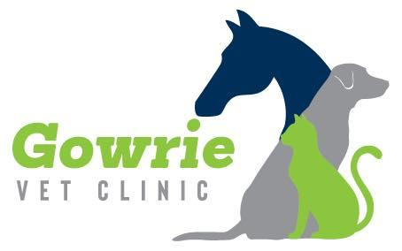

**NOVICE FINAL**

**SATURDAY 1st March 2025**



**3. NUTRIEN AG SOLUTIONS OPEN DRAFT**

Nomination: $50 *(including GST)*

Prizemoney: $1360

**$50 Highest Cutout prize donated by IRLX**

**4. GEOFF TURNER DIESEL & EARTHMOVING LADIES DRAFT**

**(Over 17yrs, Limit of 2 runs)**

**(Subject to cattle availability) *G. O. TURNER DIESEL***

Nomination: $30 *(including GST)* ***AND EARTHMOVING***

Prizemoney: $570

**$50 Highest Cutout prize donated by IRLX**

**OPEN FINAL**

**5. WORGAN CONTRACTING JUNIOR DRAFT**

Nomination: $10 ***(Limit 2 entries)***

Prizemoney: $210

***WORGAN CONTRACTING***

**6. WORGAN CONTRACTING JUVENILE DRAFT**

Nomination: $12 ***(Limit 2 entries)***

Prizemoney: $265